
Goal

In this worksheet we will use what we learned from the topics worksheet to send robot specific messages using topics. We will publish move messages as well as subscribe to the robots camera imaging as well as other robotic systems . Apon completion you should be able to code a complete automaton robotic system. In this worksheet we are going t create a simple rumba style robot that will navigate its surroundings while avoiding obstacles.

Recap on Topics

Topic are the most common one-way communication type used in Ros. They send messages through a peer-to-peer publish /subscriber nodes. The subscriber node , listens to the publishers nodes and awaits its command. In this worksheet the turtlebot will be a subscriber to our motion commands.

Creating a new Workspace and Package

Since we will be working with lasers and geometric co-ordinates we are going to create a new workspace and package,Instead of adding extra dependences to our existing packages.

$ mkdir -p ~/Roomba/src
$ cd ~Roomba/src
$ catkin_init_workspace

Now that we have our workspace set up to store our code, we now have to set up our package which specifies our codes dependencies .

$ cd ~/wanderbot_ws/src
$ catkin_create_pkg my_roomba rospy geometry_msgs sensor_msgs

The first argument, my_roomba, is the name of the new package we want to create. The following arguments are the names of packages that the new package depends on. We must include these because the ROS build system needs to know the package dependencies in order to efficiently keep the builds up to date when source files change, and to generate any required installation dependencies when packages are released.

Python Poetry in Motion

Now that we’ve created our Roomba package, we can create a minimal ROS node inside of it. In the previous worksheet, we were just sending generic messages between nodes, such as strings or integers. Now, we can send something robot-specific.

The following code will send a stream of motion commands 10 times per second, alternating every 3 seconds between driving and stopping. When driving, the program will send forward velocity commands of 0.5 meters per second. When stopped, it will send commands of 0 meters per second.

#!/usr/bin/env python
import rospy
from geometry_msgs.msg import Twist

rospy.init_node('Light')
motion_pub = rospy.Publisher('move', Twist, queue_size=1)

stop = Twist()
go = Twist()

go.linear.x = 0.5
stop.linear.x= 0.0
Moving = False

light_change_time = rospy.Time.now()
rate = rospy.Rate(10)

while not rospy.is_shutdown():
if Moving:
motion_pub.publish(go)
else:
motion_pub.publish(stop)
if rospy.Time.now() > light_change_time:
Moving = not Moving
light_change_time = rospy.Time.now() + rospy.Duration(3)
rate.sleep()

Break down of code

from geometry_msgs.msg import Twist: this is our first new package dependency, we are importing Twist which is the main motion control package. Twist is a powerful package that allows us not only to publish move messages but to also publish the speed at which me want to move.

rospy.init_node('Light')
move = rospy.Publisher('move', Twist, queue_size=1)
Like previous topics we have made, we initialize the node which we are going to call Red_Green_Light then define what we want to publish. We are publishing a message called “move ” of type Twist with an arbitrary queue size. This will be our motion message.

Next we are going to define 2 types of motion and give them the speed at which they go forward at
stop = Twist()
go = Twist()

go.linear.x = 0.5
stop.linear.x= 0.0

while the node is running , we use a boolean to check if the robot is moving, if it is we call the stop.linear which tells the robot to drive at 0 meters per seconds. The system publishes this for our time delay then switches to the go.linear which tells the robot to drive at 0.5 meters per second .

Running the code

Save the code as Light.py in your workspace and chmod +x it .
To run the code open up 3 terminal windows

in T1 run
$ roscore

in T2 run
$ roslaunch turtlebot_gazebo turtlebot_world.launch

in T3
$ source devel/setup.bash
$ ./Light.py move:=cmd_vel_mux/input/teleop
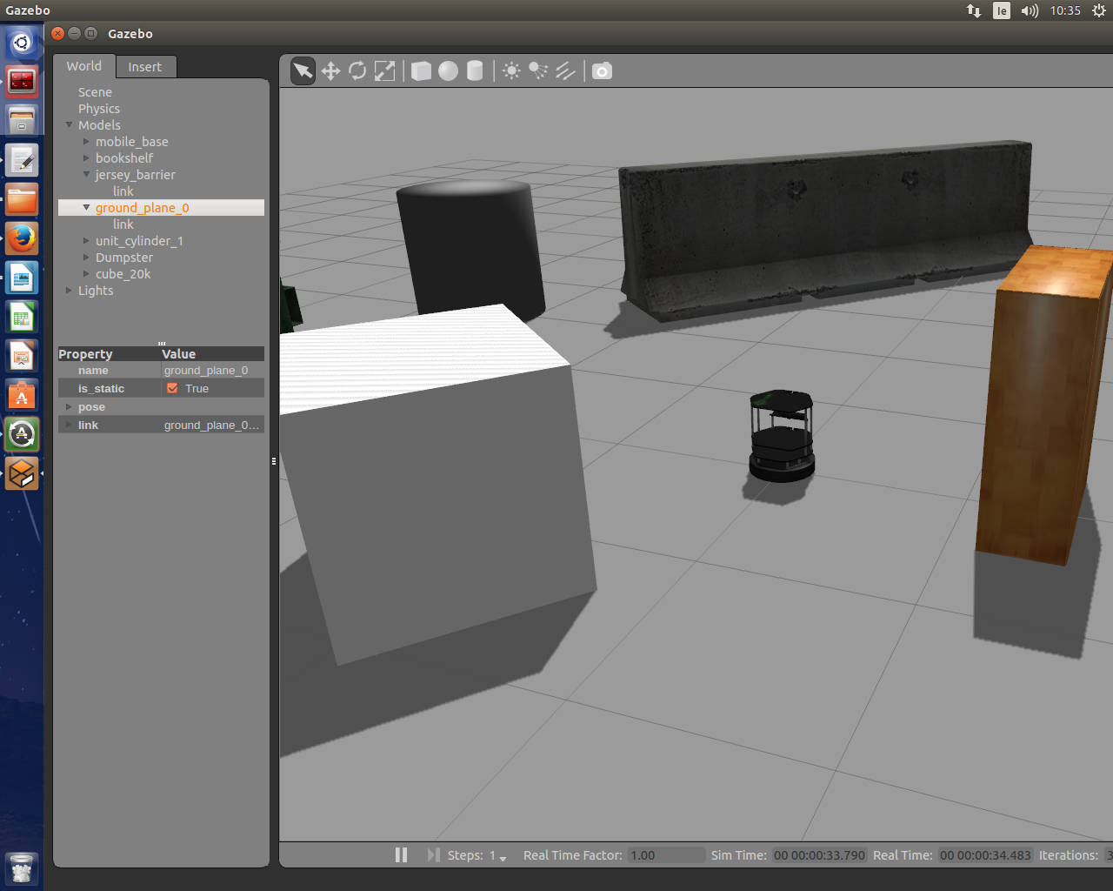
The cmd_vel remapping is necessary so that we are publishing our Twist messages to the topic that The Turtlebot software stack is expecting. Although we could have declared our “move” to publish to this topic in the Light.py source code, our usual goal is to write ROS nodes that are as generic as possible, and in this case, we can easily remap cmd_vel to whatever is required by any robot’s software stack.
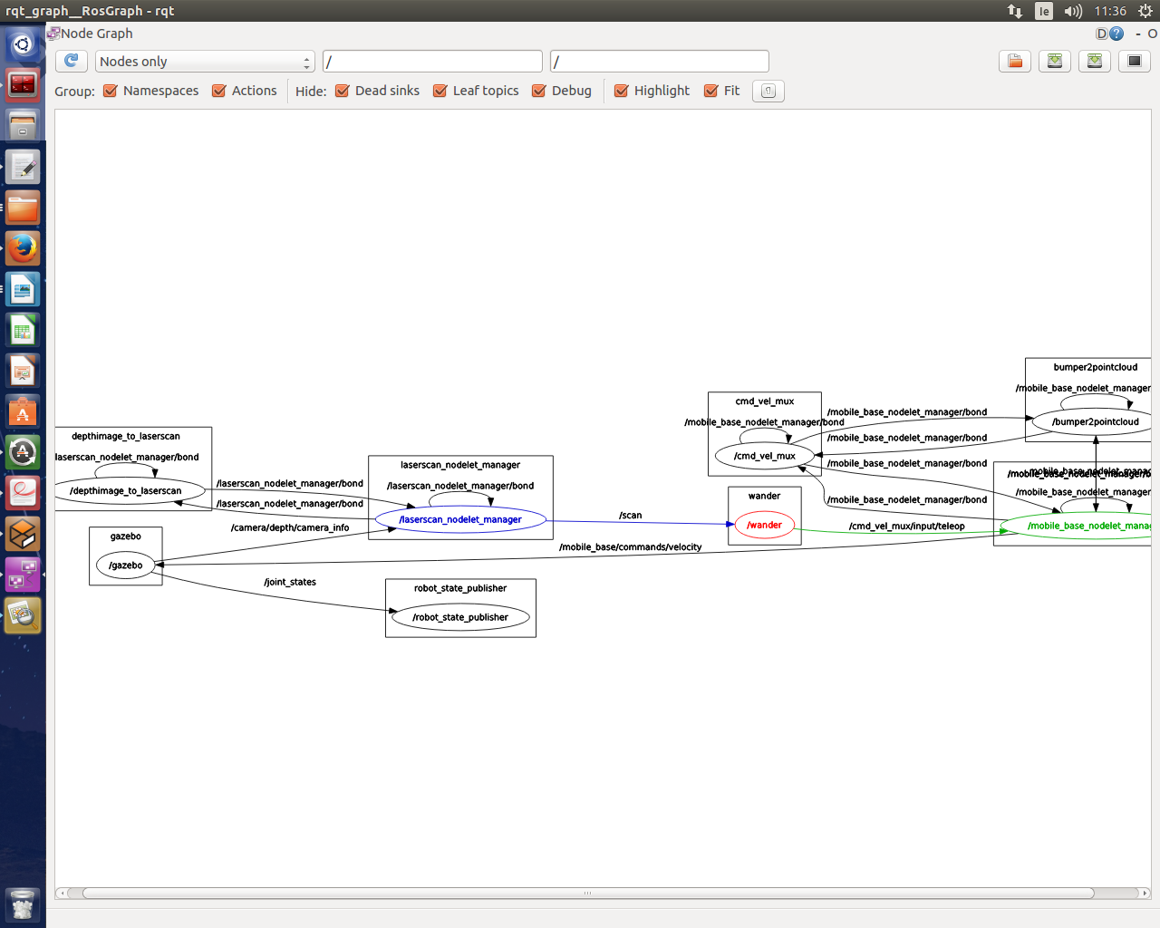

Using rosrun rqt_graph rqt_graph we can get a visual representation of which node are communicating with each other over topics.

Exercise one: Alter the givin code so the turtle bot so it drives out a lower case 'i' meaning it drives forward, stops, then drives in a circle. Hint rotary motion can be achieved by changing the 'linear' in go.linear.x = 0.5 to ' angular'.

Exercise two: Alter the give code so the turtle bot maps out the letter 'j'

Sensors

For the next part we are going to subscribe to the robots sensors. Blindly driving around is fun, but we typically want robots to use sensor data. The turtlebot is kitted out with sophisticated sensors, lasers and depth cameras. It has a kinect depth camera which publishes messages as
sensor_msgs/LaserScan messages on the scan topic.

To start using the sensors data, we can echo the scan topic to the terminal to verify that the laser is pulishing. With both roscore and gazebo running we check all topics that are being published from the turtlebot

$ rostopic list
$ rostopic echo scan

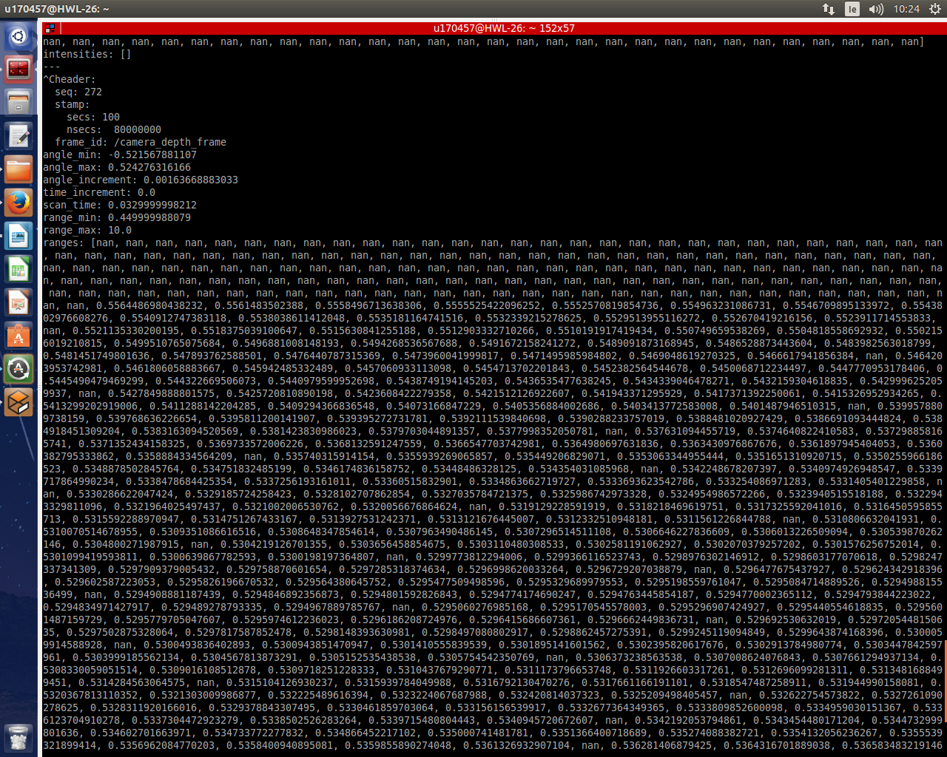

This will print a continuous stream of text that will represent the LaserScan messages. As is the raw data is unreadable we are only interested in the range[] array which contains the range from the turtlebot to its nearest object. The following callback code creates a node that subscribes to the Laser scan and using the range[] prints out readable values for the object ahead.

Exercice three: Complete the code for the subscriber node.

–--------#!/usr/bin/env python
–--------import rospy
–--------from sensor_msgs.msg import LaserScan

def scan_callback(msg):
range_ahead = msg.ranges[len(msg.ranges)/2]
print "range ahead: %0.1f" % range_ahead

–--------rospy.init_node('range_ahead')
–--------scan_sub = rospy.Subscriber('scan', LaserScan, scan_callback)
–--------rospy.spin()

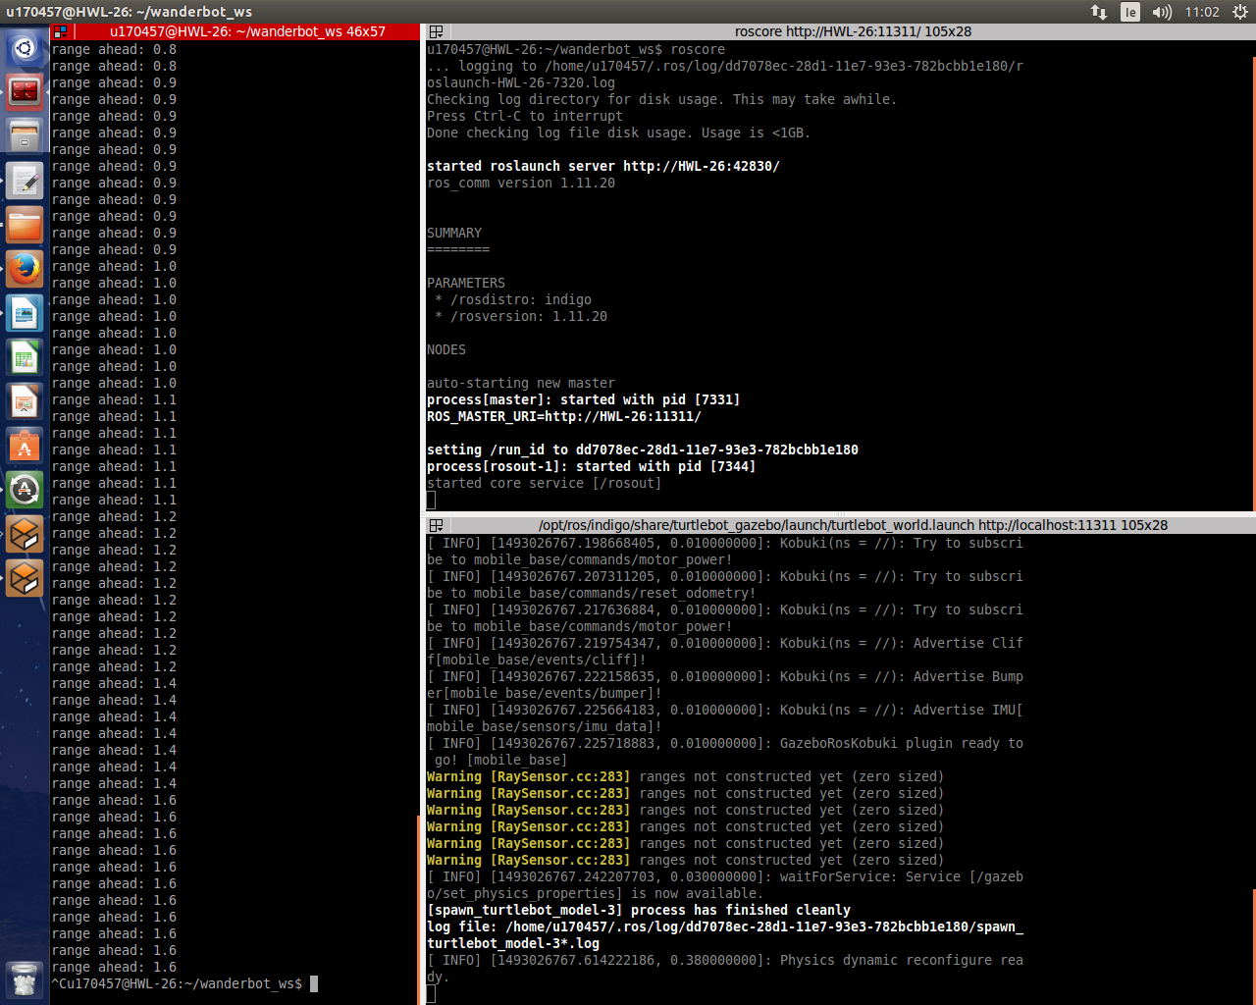
We can change the values of the range ahead by moving the turtlebot around in Gazebo. We can also alter that land scape by moving or adding objects to the world. The image below is a birds eye rendering of the laser extracted from the Kinect. Objects directly in front are visible, yet objects on either side are out of view.

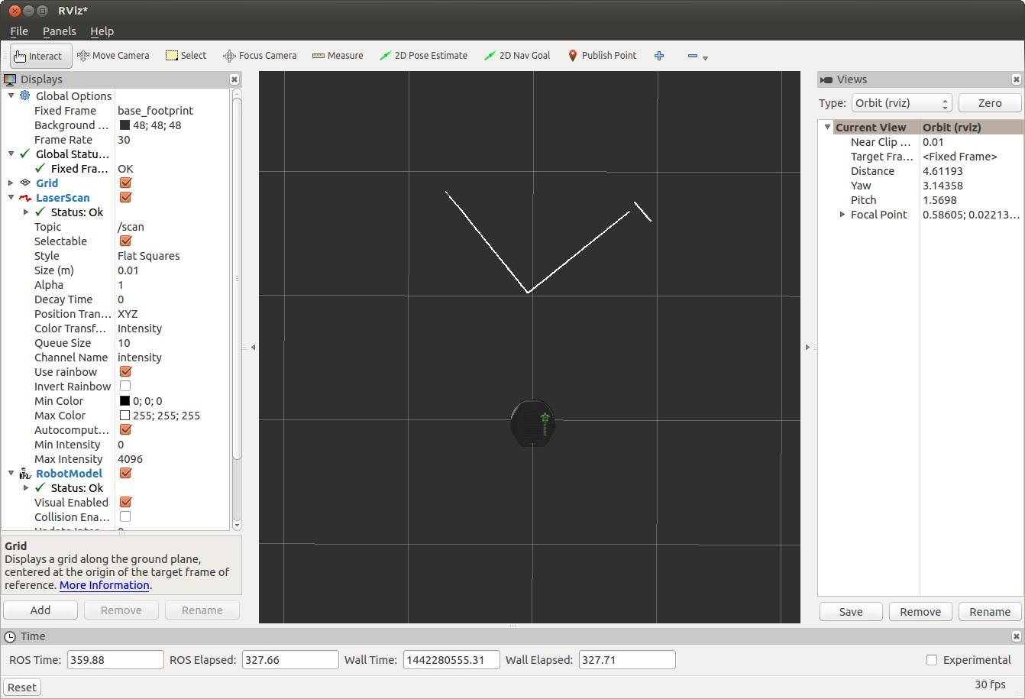

We have now written red_light_green_light.py, which causes Turtlebot to drive open-loop, and range_ahead.py, which uses the Turtlebot’s sensors to estimate the range to the nearest object directly in front of the Turtlebot. We can put these two capabilities together and write new code called Roomba.py

#!/usr/bin/env python
import rospy
from geometry_msgs.msg import Twist
from sensor_msgs.msg import LaserScan

def scan_callback(msg):
global g_range_ahead
g_range_ahead = min(msg.ranges)
g_range_ahead = 1

scan_sub = rospy.Subscriber('scan', LaserScan, scan_callback)
motion_pub = rospy.Publisher('move', Twist, queue_size=1)
rospy.init_node('Roomba')
state_change_time = rospy.Time.now()
driving_forward = True
rate = rospy.Rate(10)

while not rospy.is_shutdown():
if driving_forward:

if (g_range_ahead < 0.9 or rospy.Time.now() > state_change_time):
driving_forward = False
state_change_time = rospy.Time.now() + rospy.Duration(5)

else:
if rospy.Time.now() > state_change_time:
driving_forward = True
state_change_time = rospy.Time.now() + rospy.Duration(30)

go = Twist()
if driving_forward:
go.linear.x = 0.5
else:
go.angular.z = 0.5
motion_pub.publish(go)

rate.sleep()

Breakdown of code

We start of with are imports , nothing new. We then define a call back since this node is subsrcibing to the Laser.
def scan_callback(msg):
global g_range_ahead
g_range_ahead = min(msg.ranges)

Callbacks, you will rememberer from the previous worksheet must be defined before the subscription. This call back simple creates a variable that will store the min distance between the robot and and object in front.

We then, like every other time set up our subscription to the topic we are going to use, in this case laser. We then set up our publication of our motion. Like the Light.py we create a boolean to check if the robot is moving

while not rospy.is_shutdown():
if driving_forward:

if (g_range_ahead < 0.9 or rospy.Time.now() > state_change_time):
driving_forward = False
state_change_time = rospy.Time.now() + rospy.Duration(5)

else:
if rospy.Time.now() > state_change_time:
driving_forward = True
state_change_time = rospy.Time.now() + rospy.Duration(30)

this section of code details the requirements for the robot to be allowed to move. We also add a time delay between switching states to allow the turtlebot to accelerate and slow down. We tell the robot not to move if theres an object within 1 meter and if it cant find an object after 30 seconds. After it stops for 5 seconds we allow it to move again provided the way in front is clear.

go = Twist()
if driving_forward:
go.linear.x = 0.5
else:
go.angular.z = 0.5
motion_pub.publish(go)

The remaining code dictates the speed at which it moves when allowed to drive and tells the robot that when its not going forward it must spin in place until the way is clear.

Running the code

save the code and chmod +x it . Dont forget to source devel/setup.bash before running .The TurtleBot will wander around aimlessly, while avoiding collisions with obstacles it can see.

Summary

In this worksheet, we first created an open-loop control system in Light.py that started and stopped the Turtlebot based on a simple timer. Then, we saw how to read the information from the Turtlebot’s depth camera. Finally, we closed the loop between sensing and actuation by creating a Roomba, a program that causes the Turtlebot to avoid obstacles and randomly wander around its environment.

